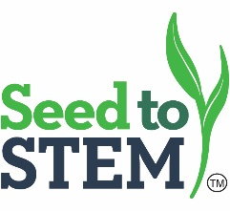
Chanute Summer Workshop ■ Middle School Track
Thursday, June 4, 2020
8:00 a.m. Registration and light breakfast
8:30 a.m. Welcome and Introductions - Sharon Thielen & Erin Rios
8:45 a.m. Explore Corn – Chris Remmich
9:45 a.m. Break
10:00 a.m. Fermentation in a Bag & Ethanol-Corn Mash & Distillation - Brian Nelson
Noon Lunch
12:45 p.m. Decoding DNA-Modeling Protein Synthesis – Jessica Sadler
1:30 p.m. Genetically Modified Information – Lacie Fair
2:30 p.m. Break
2:45 p.m. Soil Sleuth – Jessica Sadler
3:45 p.m. The Art of Lab Work-Pipetting Skills Development – Shelly Robinson
4:30 p.m. Hotel Check-in - TBA
5:30 p.m. Farm Visit – TBA
6:30 p.m. Reception
7:00 p.m. Farm Dinner

Friday, June 5, 2020
7:30 a.m. Doors Open
8:15 a.m. Soil Sleuth – Jessica Sadler
9:15 a.m. Ethanol-Corn Mash and Distillation – Brian Nelson
10:15 a.m. Break
10:30 a.m. DDG Nutrient Testing – Chris Remmich
11:00 a.m. Ethanol Expert - TBA
11:30 a.m. Break
11:45 p.m. Bus to Ethanol Plant (box lunch on bus)
1:00 p.m. Ethanol Plant Tour - Garnett
3:30 p.m. Bus to School
-Q&A
-Evaluation
4:30 p.m. Depart and Teacher Workshop Kit

