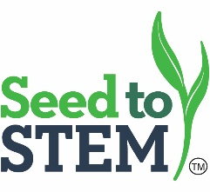
Chanute Summer Workshop ■ Middle School Track 2.0
Tuesday, June 9, 2020
9:45 a.m. Registration
10:00 a.m. Kernel Kode – Jessica Sadler
11:00 a.m. Water Conservation – Shelly Robinson
12:00 p.m. Lunch and Collaboration
12:30 p.m. 1.0 Lab Focus
1:00 p.m. Water Quality– Brent Conner
2:00 p.m. Corn Plastics-Brian Nelson
3:00 p.m. Break
3:15 p.m. Soil Erosion – Brent Conner
4:15 p.m. Field Scouting – Chris Remmich
4:45 p.m. Hotel Check-in - TBA
5:30 p.m. Farm Visit & Field Scouting Lab - TBA
6:30 p.m. Reception
7:00 p.m. Farm Dinner

Wednesday, June 10, 2020
8:00 a.m. Doors Open
8:30 a.m. Corn Plastic – Brian Nelson
8:45 a.m. Roots & Shoots – Brent Conner
9:45 a.m. DNA- How is it packaged? -Jessica Sadler
10:30 a.m. Break
10:45 a.m. Corn Genetics and Statistical Analysis – Shelly Robinson
11:45 a.m. Lunch and Collaboration
12:15 a.m. 1.0 Lab Focus
1:00 p.m. Fossil Fuels vs Biofuels – Brian Nelson
2:00 p.m. Beef Breakout– Brent Conner
2:45 p.m. Break
3:00 p.m. Mini Labs– Chris Remmich
4:30 p.m. Evaluations and Departure

