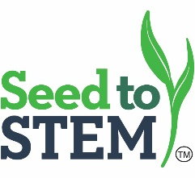
Hays Summer Workshop ■ High School Track 2.0
Thursday, June 4, 2020
9:45 a.m. Registration
9:00 a.m. Kernel Kode – Jessica Sadler
10:00 a.m. DNA-What does it look like? – Bill Welch
11:00 a.m. Break
11:15 a.m. Corn Genetics and Statistical Analysis – Shelly Robinson
12:00 p.m. Lunch and Collaboration
12:15 p.m. 1.0 Lab Focus
1:15 p.m. Biodiesel– James Burk
2:15 p.m. Break
2:30 p.m. Water, Water, Everywhere – Lacie Fair
3:45 p.m. Field Scouting – Chris Remmich
4:30 p.m. Hotel Check-in - TBA
5:30 p.m. Farm Visit & Field Scouting Lab - TBA
6:30 p.m. Reception
7:00 p.m. Farm Dinner

Friday, June 5, 2020
7:30 a.m. Doors Open
8:00 a.m. Biodiesel and Ethanol Expert – James Burk
9:00 a.m. Do you know your Moo? – Brent Conner
9:45 a.m. Break
10:00 a.m. Yield by Design– Lacie Fair
11:15 a.m. GMO or GMNO – Bill Welch
12:00 a.m. Lunch and Collaboration
12:30 a.m. 1.0 Lab Focus
1:00 p.m. GMO or GM-NO – Bill Welch
2:00 p.m. Break
2:15 p.m. Chemical Application– Lacie Fair
3:15 p.m. Plant Tissue Culture/Mini Labs– Chris Remmich
4:30 p.m. Evaluations and Departure

